Muhammad Budi Setiawan  
22/505064/TK/55254

**TASK 3: DB BENCHMARKING OPERATIONS**

DB Benchmarking adalah pengukuran dan evaluasi kinerja dari basis data. DB Benchmarking dilakukan untuk mengetahui efisiensi dari basis data yang telah dibuat supaya bisa mengetahui workload yang mampu ditangani oleh basis data. DB Benchmarking dilakukan pada basis data Good Reading Bookstore Database yaitu pada API yang telah dibuat apa GRB API. Terdapat 11 Endpoint pada API tersebut seperti pada lampiran.

Benchmark dilakukan dengan mengumpulkan data kecepatan eksekusi antara Postgre SQL, Postman dengan pengiriman sekali, Postman dengan pengiriman berkali-kali. Postman sekali kirim memiliki rata-rata paling besar sebesar 89,15 ms dan standard deviasi sebesar 23,36 ms. Pemilik rata-rata terbesar kedua yaitu Postgre SQL dengan nilai sebesar 59,12 dan standard deviasi sebesar 17,7 ms.

Berdasarkan plot setiap endpoint yang ada pada lampiran, terlihat kecepatan eksekusi query yang dilakukan oleh postgre SQL, Postman dengan satu kali pengiriman, dan Postman dengan pengiriman terus menerus. Kecepatan eskekusi dari postman sekali kirim terlihat paling besar dibandingkan dengan kecepatan lain. Hal tersebut berbanding terbalik dengan kecepatan eksekusi dari Postman yang dikirim secara terus menerus dimana kecepatan runtime jauh terlihat lebih cepat dibandingkan yang lain.

Berdasarkan plot setiap metode, persebaran eksekusi terlihat bahwa Postman sekali kirim memiliki runtime terlama, disusul Postgre SQL dan Postman berkali-kali kirim. Pada methods GET dan POST pada Postman berkali-kali kirim memiliki kecepatan yang jauh lebih cepat dari pada yang lain karena persebaran waktu eksekusi terpusan pada sebelah kiri. Pada methode PUT dan DELETE juga menunjukkan hasil yang serupa namun dengan selisih yang tidak terlalu menojol seperti pada methods GET dan POST.

Uji Paired T dilakukan untuk mengetahui kecepatan paling besar atau paling lama diantara Postgre SQL, Postman dengan sekali kirim, dan Postman dengan berkali-kali kirim. Tingkat pengujian dilakukan 3 kali yaitu antara Postman sekali kirim dan Postgre SQL, Postgre SQL dan Postman dengan berkali-kali kirim, serta yang terakhir antara Postman sekali kirim dengan Postman berkali-kali kirim. Pengujian dilakukan dengan tingkat kepercayaan sebesar 95%. Pada pengujian pertama antara Postman sekali kirim dan Postgre SQL diketahui nilai probabilitas sebesar 5,72E-37 bernilai kurang dari alpha sebesar 0,05 sehingga dapat disimpulkan bahwa Postman sekali kirim memiliki kecepatan eksekusi lebih lama dibandingkan dengan Postgre SQL.Pada pengujian antara Postgre SQL dan Postman berkali-kali kirim, nilai probabilitas lebih kecil dari pada 0,05 sehingga dapat disimpulkan bahwa Postgre SQL memiliki kecepatan eksekusi lebih lama dibandingkan dengan Postman berkali-kali kirim. Pada pengujian terakhir juga terjadi hal serupa sehingga dapat disimpulkan bahwa Postman yang dirikim sekali lebih lama dibandingkan dengan Postman yang dikirim berkali-kali.

Pada DB Benchmarking Operation, kecepatan eksekusi menggunakan Postman dapat lebih cepat maupun lebih lambat daripada Postgre SQL bergantung bagaimana cara pengiriman. Pengiriman secara sekali akan lebih lama dibandingkan pengiriman berkali-kali secara berurutan. Pengiriman pertama akan lebih lama karena postman api belum mengoptimalisasi eksekusi tersebut. Pada pengiriman berkali-kali dapat lebih optimal karena dapat menggunakan cache dalam eksekusi. Postman dapat menyimpan respon dari endpoint yang sering digunakan sehingga dapat mengurangi beban langsung dari basis data.

Lampiran Hasil Pengumpulan Data

|  |  |  |  |  |  |  |
| --- | --- | --- | --- | --- | --- | --- |
| No | Iterasi | Endpoint | Methods | Postgre SQL | Postman One Time | Postman Continue |
| 1 | 1 | showAllBooks | GET | 136 | 69 | 4 |
| 2 | 2 | showAllBooks | GET | 63 | 65 | 6 |
| 3 | 3 | showAllBooks | GET | 74 | 73 | 5 |
| 4 | 4 | showAllBooks | GET | 52 | 63 | 5 |
| 5 | 5 | showAllBooks | GET | 40 | 71 | 5 |
| 6 | 6 | showAllBooks | GET | 46 | 65 | 4 |
| 7 | 7 | showAllBooks | GET | 55 | 71 | 4 |
| 8 | 8 | showAllBooks | GET | 65 | 64 | 4 |
| 9 | 9 | showAllBooks | GET | 63 | 62 | 7 |
| 10 | 10 | showAllBooks | GET | 57 | 68 | 5 |
| 11 | 11 | showAllBooks | GET | 61 | 66 | 4 |
| 12 | 12 | showAllBooks | GET | 60 | 69 | 5 |
| 13 | 13 | showAllBooks | GET | 56 | 68 | 5 |
| 14 | 14 | showAllBooks | GET | 40 | 66 | 5 |
| 15 | 15 | showAllBooks | GET | 43 | 72 | 5 |
| 16 | 16 | showAllBooks | GET | 40 | 74 | 6 |
| 17 | 17 | showAllBooks | GET | 62 | 72 | 4 |
| 18 | 18 | showAllBooks | GET | 56 | 74 | 4 |
| 19 | 19 | showAllBooks | GET | 65 | 64 | 4 |
| 20 | 20 | showAllBooks | GET | 56 | 69 | 5 |
| 21 | 1 | showBooksRating | GET | 132 | 65 | 11 |
| 22 | 2 | showBooksRating | GET | 66 | 70 | 7 |
| 23 | 3 | showBooksRating | GET | 57 | 64 | 5 |
| 24 | 4 | showBooksRating | GET | 53 | 66 | 5 |
| 25 | 5 | showBooksRating | GET | 51 | 69 | 4 |
| 26 | 6 | showBooksRating | GET | 70 | 71 | 5 |
| 27 | 7 | showBooksRating | GET | 64 | 64 | 5 |
| 28 | 8 | showBooksRating | GET | 60 | 64 | 5 |
| 29 | 9 | showBooksRating | GET | 55 | 65 | 7 |
| 30 | 10 | showBooksRating | GET | 50 | 65 | 9 |
| 31 | 11 | showBooksRating | GET | 67 | 71 | 7 |
| 32 | 12 | showBooksRating | GET | 53 | 64 | 6 |
| 33 | 13 | showBooksRating | GET | 55 | 67 | 5 |
| 34 | 14 | showBooksRating | GET | 36 | 68 | 4 |
| 35 | 15 | showBooksRating | GET | 39 | 66 | 5 |
| 36 | 16 | showBooksRating | GET | 44 | 66 | 46 |
| 37 | 17 | showBooksRating | GET | 59 | 71 | 9 |
| 38 | 18 | showBooksRating | GET | 75 | 71 | 6 |
| 39 | 19 | showBooksRating | GET | 55 | 71 | 5 |
| 40 | 20 | showBooksRating | GET | 53 | 69 | 6 |
| 41 | 1 | showAllReviews | GET | 64 | 68 | 8 |
| 42 | 2 | showAllReviews | GET | 38 | 63 | 8 |
| 43 | 3 | showAllReviews | GET | 60 | 64 | 4 |
| 44 | 4 | showAllReviews | GET | 67 | 65 | 8 |
| 45 | 5 | showAllReviews | GET | 57 | 78 | 4 |
| 46 | 6 | showAllReviews | GET | 70 | 64 | 5 |
| 47 | 7 | showAllReviews | GET | 67 | 65 | 4 |
| 48 | 8 | showAllReviews | GET | 57 | 69 | 4 |
| 49 | 9 | showAllReviews | GET | 58 | 65 | 8 |
| 50 | 10 | showAllReviews | GET | 62 | 64 | 43 |
| 51 | 11 | showAllReviews | GET | 39 | 76 | 4 |
| 52 | 12 | showAllReviews | GET | 39 | 78 | 5 |
| 53 | 13 | showAllReviews | GET | 42 | 75 | 5 |
| 54 | 14 | showAllReviews | GET | 39 | 72 | 5 |
| 55 | 15 | showAllReviews | GET | 39 | 76 | 6 |
| 56 | 16 | showAllReviews | GET | 37 | 64 | 4 |
| 57 | 17 | showAllReviews | GET | 40 | 66 | 5 |
| 58 | 18 | showAllReviews | GET | 39 | 77 | 4 |
| 59 | 19 | showAllReviews | GET | 55 | 74 | 5 |
| 60 | 20 | showAllReviews | GET | 39 | 63 | 5 |
| 61 | 1 | showAllWishlist | GET | 66 | 64 | 10 |
| 62 | 2 | showAllWishlist | GET | 169 | 102 | 5 |
| 63 | 3 | showAllWishlist | GET | 43 | 89 | 5 |
| 64 | 4 | showAllWishlist | GET | 37 | 99 | 5 |
| 65 | 5 | showAllWishlist | GET | 49 | 89 | 5 |
| 66 | 6 | showAllWishlist | GET | 44 | 97 | 5 |
| 67 | 7 | showAllWishlist | GET | 40 | 85 | 5 |
| 68 | 8 | showAllWishlist | GET | 40 | 87 | 6 |
| 69 | 9 | showAllWishlist | GET | 53 | 90 | 5 |
| 70 | 10 | showAllWishlist | GET | 69 | 107 | 5 |
| 71 | 11 | showAllWishlist | GET | 55 | 86 | 5 |
| 72 | 12 | showAllWishlist | GET | 50 | 97 | 48 |
| 73 | 13 | showAllWishlist | GET | 39 | 90 | 5 |
| 74 | 14 | showAllWishlist | GET | 39 | 87 | 5 |
| 75 | 15 | showAllWishlist | GET | 70 | 85 | 5 |
| 76 | 16 | showAllWishlist | GET | 36 | 95 | 5 |
| 77 | 17 | showAllWishlist | GET | 66 | 90 | 5 |
| 78 | 18 | showAllWishlist | GET | 58 | 103 | 5 |
| 79 | 19 | showAllWishlist | GET | 59 | 101 | 5 |
| 80 | 20 | showAllWishlist | GET | 59 | 95 | 5 |
| 81 | 1 | addWishlist | POST | 143 | 72 | 8 |
| 82 | 2 | addWishlist | POST | 67 | 89 | 8 |
| 83 | 3 | addWishlist | POST | 50 | 85 | 7 |
| 84 | 4 | addWishlist | POST | 45 | 89 | 7 |
| 85 | 5 | addWishlist | POST | 76 | 85 | 6 |
| 86 | 6 | addWishlist | POST | 66 | 162 | 5 |
| 87 | 7 | addWishlist | POST | 67 | 177 | 6 |
| 88 | 8 | addWishlist | POST | 57 | 124 | 7 |
| 89 | 9 | addWishlist | POST | 59 | 85 | 6 |
| 90 | 10 | addWishlist | POST | 67 | 84 | 7 |
| 91 | 11 | addWishlist | POST | 81 | 94 | 5 |
| 92 | 12 | addWishlist | POST | 67 | 105 | 6 |
| 93 | 13 | addWishlist | POST | 62 | 87 | 6 |
| 94 | 14 | addWishlist | POST | 67 | 83 | 8 |
| 95 | 15 | addWishlist | POST | 67 | 89 | 5 |
| 96 | 16 | addWishlist | POST | 43 | 82 | 8 |
| 97 | 17 | addWishlist | POST | 70 | 83 | 5 |
| 98 | 18 | addWishlist | POST | 61 | 139 | 8 |
| 99 | 19 | addWishlist | POST | 57 | 94 | 8 |
| 100 | 20 | addWishlist | POST | 82 | 86 | 5 |
| 101 | 1 | deleteWishlist | DELETE | 78 | 61 | 58 |
| 102 | 2 | deleteWishlist | DELETE | 60 | 170 | 56 |
| 103 | 3 | deleteWishlist | DELETE | 61 | 159 | 56 |
| 104 | 4 | deleteWishlist | DELETE | 61 | 105 | 6 |
| 105 | 5 | deleteWishlist | DELETE | 60 | 86 | 9 |
| 106 | 6 | deleteWishlist | DELETE | 59 | 77 | 50 |
| 107 | 7 | deleteWishlist | DELETE | 77 | 77 | 7 |
| 108 | 8 | deleteWishlist | DELETE | 41 | 85 | 49 |
| 109 | 9 | deleteWishlist | DELETE | 66 | 99 | 54 |
| 110 | 10 | deleteWishlist | DELETE | 58 | 127 | 58 |
| 111 | 11 | deleteWishlist | DELETE | 59 | 80 | 7 |
| 112 | 12 | deleteWishlist | DELETE | 62 | 90 | 7 |
| 113 | 13 | deleteWishlist | DELETE | 55 | 82 | 61 |
| 114 | 14 | deleteWishlist | DELETE | 63 | 86 | 61 |
| 115 | 15 | deleteWishlist | DELETE | 57 | 95 | 13 |
| 116 | 16 | deleteWishlist | DELETE | 57 | 93 | 10 |
| 117 | 17 | deleteWishlist | DELETE | 61 | 83 | 9 |
| 118 | 18 | deleteWishlist | DELETE | 63 | 90 | 6 |
| 119 | 19 | deleteWishlist | DELETE | 61 | 89 | 5 |
| 120 | 20 | deleteWishlist | DELETE | 56 | 89 | 12 |
| 121 | 1 | AddReviews | POST | 50 | 102 | 71 |
| 122 | 2 | AddReviews | POST | 52 | 82 | 47 |
| 123 | 3 | AddReviews | POST | 88 | 64 | 11 |
| 124 | 4 | AddReviews | POST | 72 | 86 | 6 |
| 125 | 5 | AddReviews | POST | 56 | 88 | 6 |
| 126 | 6 | AddReviews | POST | 47 | 83 | 5 |
| 127 | 7 | AddReviews | POST | 70 | 98 | 5 |
| 128 | 8 | AddReviews | POST | 63 | 99 | 9 |
| 129 | 9 | AddReviews | POST | 60 | 83 | 10 |
| 130 | 10 | AddReviews | POST | 64 | 111 | 8 |
| 131 | 11 | AddReviews | POST | 75 | 87 | 7 |
| 132 | 12 | AddReviews | POST | 76 | 78 | 7 |
| 133 | 13 | AddReviews | POST | 57 | 79 | 6 |
| 134 | 14 | AddReviews | POST | 85 | 82 | 6 |
| 135 | 15 | AddReviews | POST | 54 | 100 | 6 |
| 136 | 16 | AddReviews | POST | 79 | 83 | 10 |
| 137 | 17 | AddReviews | POST | 56 | 84 | 6 |
| 138 | 18 | AddReviews | POST | 47 | 115 | 5 |
| 139 | 19 | AddReviews | POST | 71 | 98 | 6 |
| 140 | 1 | UpdateReviews | PUT | 55 | 99 | 12 |
| 141 | 2 | UpdateReviews | PUT | 74 | 90 | 7 |
| 142 | 3 | UpdateReviews | PUT | 45 | 82 | 8 |
| 143 | 4 | UpdateReviews | PUT | 49 | 84 | 8 |
| 144 | 5 | UpdateReviews | PUT | 46 | 95 | 16 |
| 145 | 6 | UpdateReviews | PUT | 48 | 86 | 9 |
| 146 | 7 | UpdateReviews | PUT | 47 | 96 | 10 |
| 147 | 8 | UpdateReviews | PUT | 48 | 88 | 11 |
| 148 | 9 | UpdateReviews | PUT | 74 | 81 | 9 |
| 149 | 10 | UpdateReviews | PUT | 69 | 83 | 63 |
| 150 | 11 | UpdateReviews | PUT | 63 | 102 | 11 |
| 151 | 12 | UpdateReviews | PUT | 47 | 101 | 14 |
| 152 | 13 | UpdateReviews | PUT | 64 | 98 | 8 |
| 153 | 14 | UpdateReviews | PUT | 69 | 95 | 6 |
| 154 | 15 | UpdateReviews | PUT | 72 | 91 | 7 |
| 155 | 16 | UpdateReviews | PUT | 65 | 80 | 6 |
| 156 | 17 | UpdateReviews | PUT | 49 | 84 | 10 |
| 157 | 18 | UpdateReviews | PUT | 61 | 92 | 8 |
| 158 | 19 | UpdateReviews | PUT | 70 | 105 | 14 |
| 159 | 20 | UpdateReviews | PUT | 55 | 99 | 9 |
| 160 | 1 | UpdateReviews | PUT | 46 | 93 | 7 |
| 161 | 2 | DeleteReviews | DELETE | 35 | 85 | 8 |
| 162 | 3 | DeleteReviews | DELETE | 42 | 85 | 7 |
| 163 | 4 | DeleteReviews | DELETE | 56 | 168 | 9 |
| 164 | 5 | DeleteReviews | DELETE | 52 | 93 | 6 |
| 165 | 6 | DeleteReviews | DELETE | 36 | 83 | 7 |
| 166 | 7 | DeleteReviews | DELETE | 41 | 141 | 6 |
| 167 | 8 | DeleteReviews | DELETE | 43 | 85 | 6 |
| 168 | 9 | DeleteReviews | DELETE | 66 | 82 | 5 |
| 169 | 10 | DeleteReviews | DELETE | 44 | 103 | 8 |
| 170 | 11 | DeleteReviews | DELETE | 85 | 82 | 7 |
| 171 | 12 | DeleteReviews | DELETE | 41 | 82 | 5 |
| 172 | 13 | DeleteReviews | DELETE | 63 | 81 | 4 |
| 173 | 14 | DeleteReviews | DELETE | 69 | 92 | 6 |
| 174 | 15 | DeleteReviews | DELETE | 39 | 88 | 6 |
| 175 | 16 | DeleteReviews | DELETE | 35 | 81 | 7 |
| 176 | 17 | DeleteReviews | DELETE | 80 | 88 | 6 |
| 177 | 18 | DeleteReviews | DELETE | 40 | 94 | 5 |
| 178 | 19 | DeleteReviews | DELETE | 74 | 106 | 6 |
| 179 | 20 | DeleteReviews | DELETE | 51 | 82 | 8 |
| 180 | 1 | addRecommendExistPublisher | POST | 34 | 100 | 5 |
| 181 | 2 | addRecommendExistPublisher | POST | 52 | 95 | 8 |
| 182 | 3 | addRecommendExistPublisher | POST | 75 | 91 | 8 |
| 183 | 4 | addRecommendExistPublisher | POST | 87 | 97 | 4 |
| 184 | 5 | addRecommendExistPublisher | POST | 74 | 94 | 5 |
| 185 | 6 | addRecommendExistPublisher | POST | 72 | 88 | 4 |
| 186 | 7 | addRecommendExistPublisher | POST | 66 | 90 | 5 |
| 187 | 8 | addRecommendExistPublisher | POST | 65 | 104 | 5 |
| 188 | 9 | addRecommendExistPublisher | POST | 62 | 152 | 5 |
| 189 | 10 | addRecommendExistPublisher | POST | 71 | 85 | 5 |
| 190 | 11 | addRecommendExistPublisher | POST | 63 | 89 | 5 |
| 191 | 12 | addRecommendExistPublisher | POST | 69 | 87 | 5 |
| 192 | 13 | addRecommendExistPublisher | POST | 82 | 138 | 5 |
| 193 | 14 | addRecommendExistPublisher | POST | 61 | 114 | 4 |
| 194 | 15 | addRecommendExistPublisher | POST | 63 | 99 | 5 |
| 195 | 16 | addRecommendExistPublisher | POST | 70 | 128 | 40 |
| 196 | 17 | addRecommendExistPublisher | POST | 60 | 97 | 6 |
| 197 | 18 | addRecommendExistPublisher | POST | 63 | 130 | 5 |
| 198 | 19 | addRecommendExistPublisher | POST | 63 | 97 | 5 |
| 199 | 20 | addRecommendExistPublisher | POST | 70 | 88 | 5 |
| 200 | 1 | addRecommendNewPublisher | POST | 56 | 84 | 6 |
| 201 | 2 | addRecommendNewPublisher | POST | 48 | 182 | 4 |
| 202 | 3 | addRecommendNewPublisher | POST | 45 | 109 | 10 |
| 203 | 4 | addRecommendNewPublisher | POST | 68 | 86 | 5 |
| 204 | 5 | addRecommendNewPublisher | POST | 73 | 91 | 5 |
| 205 | 6 | addRecommendNewPublisher | POST | 37 | 83 | 6 |
| 206 | 7 | addRecommendNewPublisher | POST | 77 | 89 | 7 |
| 207 | 8 | addRecommendNewPublisher | POST | 35 | 88 | 6 |
| 208 | 9 | addRecommendNewPublisher | POST | 60 | 174 | 4 |
| 209 | 10 | addRecommendNewPublisher | POST | 39 | 82 | 5 |
| 210 | 11 | addRecommendNewPublisher | POST | 39 | 195 | 5 |
| 211 | 12 | addRecommendNewPublisher | POST | 64 | 86 | 8 |
| 212 | 13 | addRecommendNewPublisher | POST | 36 | 123 | 5 |
| 213 | 14 | addRecommendNewPublisher | POST | 80 | 135 | 7 |
| 214 | 15 | addRecommendNewPublisher | POST | 48 | 90 | 9 |
| 215 | 16 | addRecommendNewPublisher | POST | 43 | 86 | 9 |
| 216 | 17 | addRecommendNewPublisher | POST | 115 | 137 | 9 |
| 217 | 18 | addRecommendNewPublisher | POST | 45 | 82 | 10 |
| 218 | 19 | addRecommendNewPublisher | POST | 47 | 92 | 9 |
| 219 | 20 | addRecommendNewPublisher | POST | 39 | 86 | 9 |

Lampiran Plot Setiap Endpoint

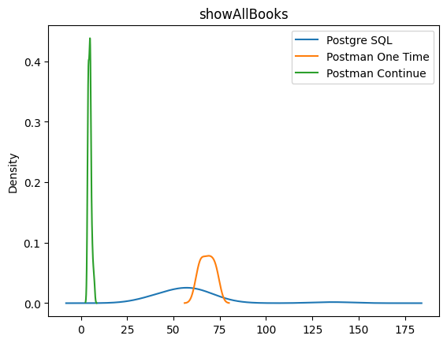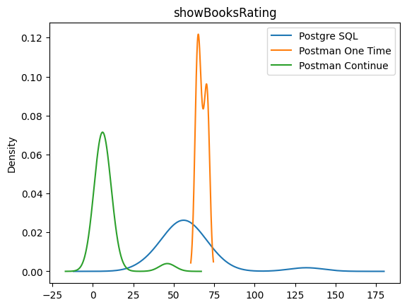

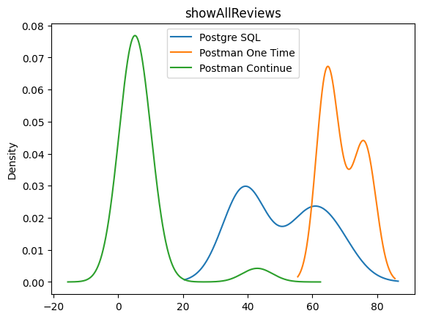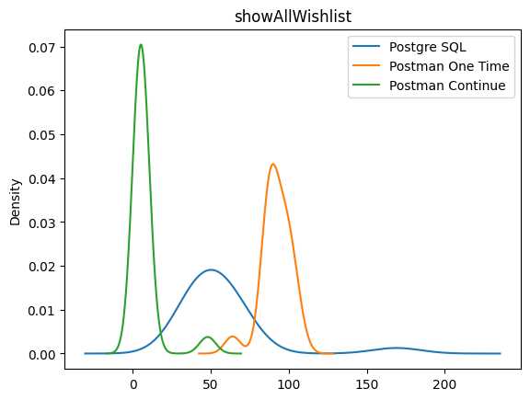

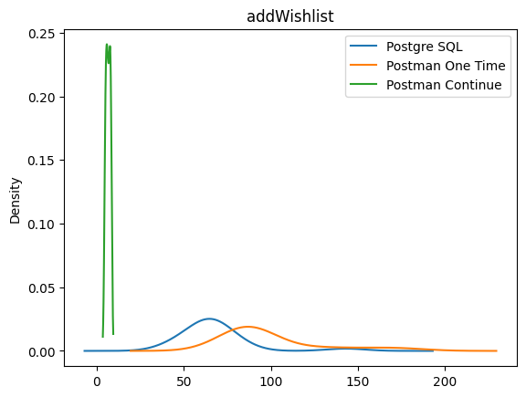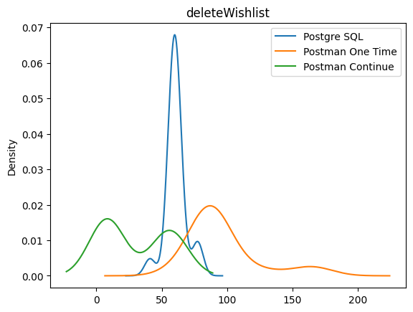

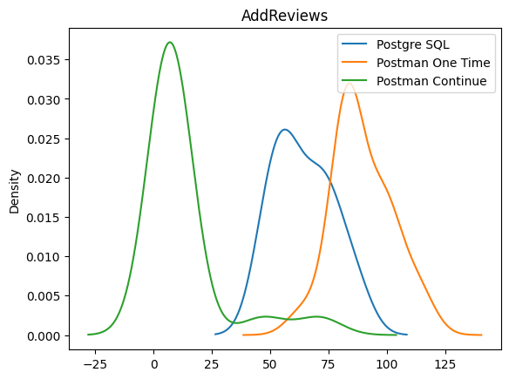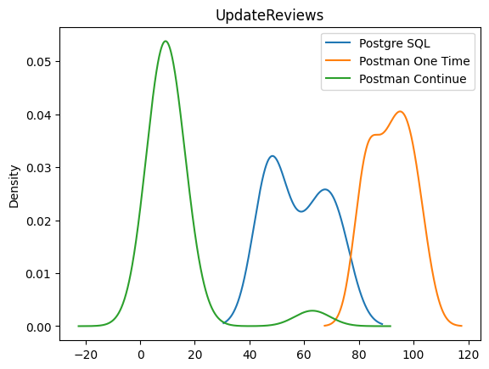

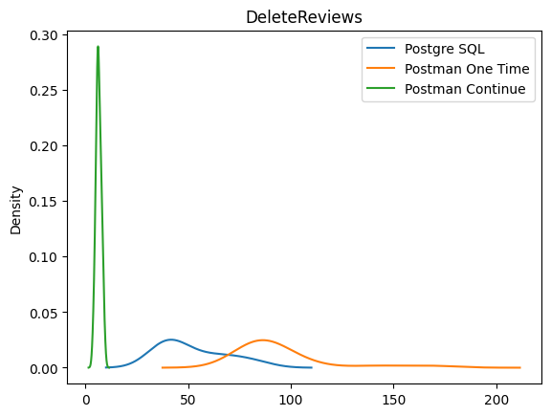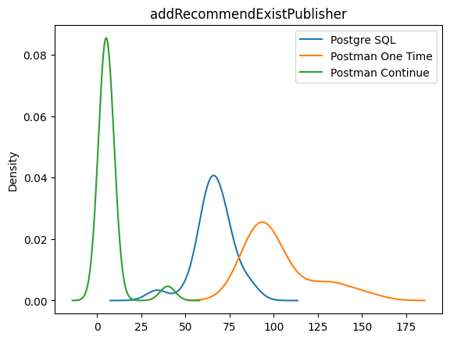

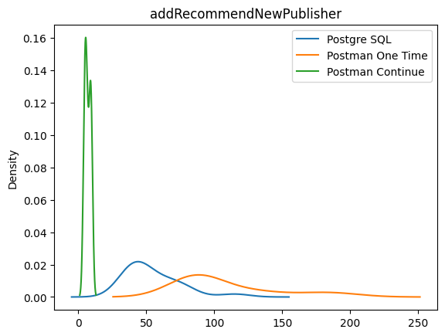

Lampiran Plot Setiap Methods

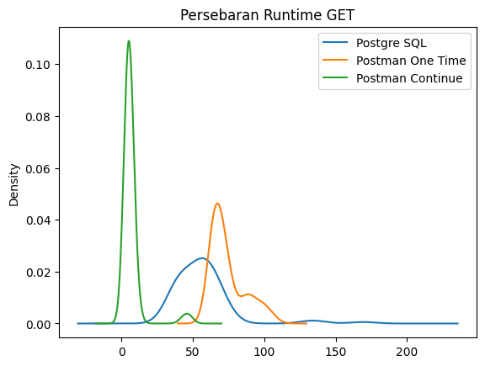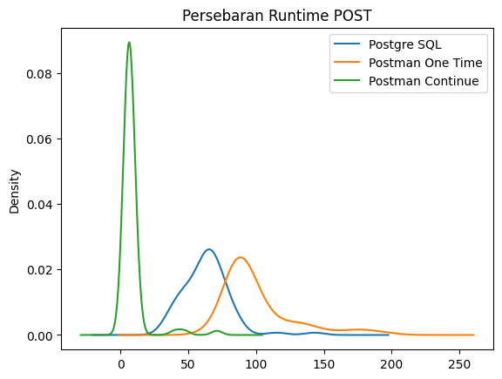

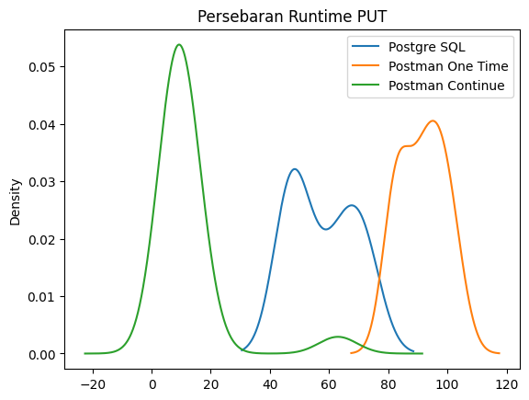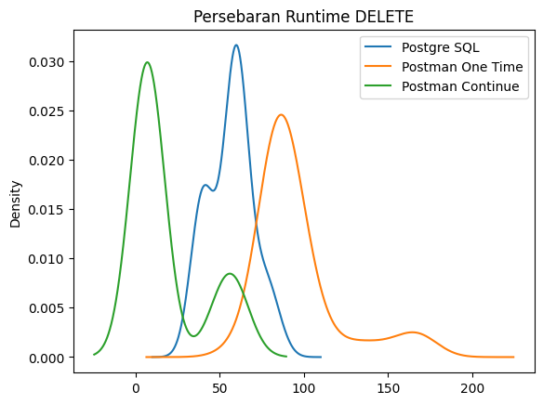

Lampiran Uji Paired T Test 





https://github.com/itproject-2k22/GRD-DB-Benchmarking-Operation